|  |  |  |  |
| --- | --- | --- | --- |
|  | **European Commission**  **DIRECTORATE GENERAL**  <INFORMATICS> | **logo RUP@EC-Fixed-v1** |  |

**e-TrustEx – Submit Document Bundle Use Case Specification**

|  |
| --- |
| *---- Remove this text box after reading ---*  Help text for this Artifact Template Version 2012-01  ***Key to symbols used in this template:***  *[] indicates text to be replaced by the user of this template.*  *<> indicates text that is updated using Document Properties button.*  ***Click here to update the Document Properties >>***   * *This button is also available on the next page.*   ***Other information:***   * *Check that you are using the latest template* –[click](http://www.cc.cec/RUPatEC/) * *While working on the document, you may choose to leave some of the blue text guidance.* |

**Document Control Information** 

|  |  |
| --- | --- |
| **Settings** | **Value** |
| **Directorate:** | <INFORMATICS> |
| **Project Name:** | e-TrustEx |
| **Document Author:** | Alice Vasilescu |
| **System Owner:** | Tanya Chetcutti |
| **Project Manager:** | Tanya Chetcutti |
| **Revision Status:** | Draft |
| **Sensitivity:** | Limited DG |
| **Issue Date:** | <Issue Date> |

**Document Approver(s):**

(All Approvers are required. Records of each approver must be maintained.)

|  |  |
| --- | --- |
| **Approver Name** | **Role** |
| [Name] | [Role] |
|  |  |
|  |  |

**Document Reviewers:** (Records of each required reviewer must be maintained.)

|  |  |
| --- | --- |
| **Reviewer Name** | **Role** |
| [Name] | [Role] |
|  |  |
|  |  |

NOTE: All Reviewers in the list are considered required unless explicitly listed as Optional.

**Summary of Changes:**

The Document Author is authorized to make the following types of changes to the document without requiring that the document be re-approved:

* Editorial, formatting, and spelling
* Clarification

To request a change to this document, contact the Document Author or Owner.

Changes to this document are summarized in the following table in reverse chronological order (latest version first).

|  |  |  |  |
| --- | --- | --- | --- |
| **Revision** | **Date** | **Created by** | **Short Description of Changes** |
| [0.1] | [06/21/2013] | [Alice Vasilescu] | [Initial Version of approved document] |
| [0.2-0.3] | [09/25/2013] | [Alice Vasilescu] | [Internal review] |
| [0.04] | [05/07/2014] | [Alice Vasilescu] | [Update status] |

**Configuration Management: Document Location**

The latest version of this controlled document is stored in [this location].

Contents

1. Use Case description 4

2. Flow of events 4

2.1. Basic flow 4

2.1.1. System performs specific checks 4

2.2. Exceptional flows 4

E1 at Step 2.1.1"System performs specific checks" and RULE387 fails 4

E1 at Step 2.1.1"System performs specific checks" and RULE274 fails 4

2.3. Subflow 5

S1. Persist message upon failure 5

3. Special Requirements 5

4. Preconditions 5

5. Post conditions 5

6. Additional Information 5

# Use Case description

This Use Case describes the specific processing performed by e-TrustEx on a business document of type DocumentBundle. This Use Case extends the Submit Document Use Case.

# Flow of events

# Basic flow

# System performs specific checks

* This Use Case extends the UC1_1_1. Asynchronous+Service+Use+Case+Specification and it is called from “Step 2.8 System performs the business specific processing”

|  |  |  |  |  |  |
| --- | --- | --- | --- | --- | --- |
| ID | Description | Element path | Severity | Category | Subcategory |
| RULE387 | DocumentBundle.DocumentReference must be unique | N/A | Hard | Message body check | Payload type |
| RULE274 | DocumentBundle.Document Reference.ID  Must point to an existing Document Wrapper (according to the ID and the DocumentTypeCode).  This validation occurs for all the instances of DocumentReference within the Bundle message. | N/A | Hard | Message body check | Payload type |

* The Use Case ends.

# Alternative flow

# System checks if an “AVAILABLE” notification is needed

* The system checks if the ScopeAttribute in the header is field with “CREATE_STATUS_AVAILABLE” (Header-> BusinessHeader-> BusinessScope -> Scope->ScopeAttributes-> Type);
* As the value is correctly populated, the system generates an Application Response:
  + A Response Code is added "BDL:1"
  + A Description may be added
  + The Status of the message is set to “RECEIVED”
* The Use Case ends.

# The system receives an Application Response with BDL:7

* The system receives for the Bundle an Application Response with code BDL:7
* The Status of the message is set to “READ”
* The Use Case ends.

# The system receives an Application Response with BDL:4

* The system receives for the Bundle an Application Response with code BDL:4 as a business error occured
* The Status of the message is set to “FAILED”
* The Use Case ends.

# Exceptional flows

### E1 at Step 2.1.1"System performs specific checks" and RULE387 fails

* The system performs subflow **S1. Persist message upon failure**
* The following parameters are added to the Application Response:
* A Response Code is added "BDL:4"
* A Description may be added
* The Status of the message is “ERROR”
* The use case ends.

### E1 at Step 2.1.1"System performs specific checks" and RULE274 fails

* The system performs subflow **S1. Persist message upon failure**
* The following parameters are added to the Application Response:
* A Response Code is added "BDL:6"
* A Description may be added
* The Status of the message is “ERROR”
* The Use Case ends.

# Subflow

# S1. Persist message upon failure

* The system creates an Application Response
* The system persists the Application Response and records the following information in the message table etr_tb_message:
* The date and time when the message was created
* The reference to the message binary stored in the Binary table
* The ID of the document

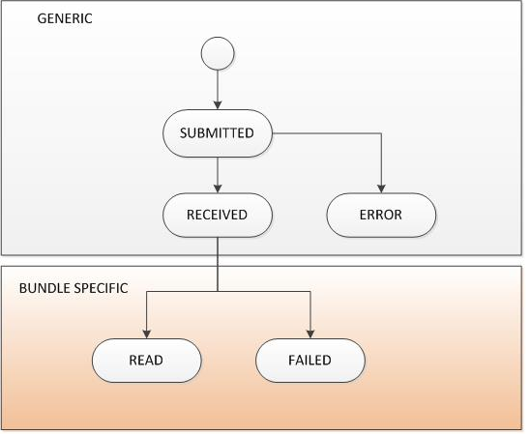

* The ID of the agreement that corresponds to this document
* The ID of the Issuer of the document
* The ID of the transaction
* The Issue date and the Receipt date
* The ID of the Receiver
* The ID of the Sender
* The message document type
* An additional entry in the binary table etr_tb_message_binary is created, storing the Application Response xml. This xml would include information regarding the document which failed during the validation process:
* If available, the ID of the document is added
* Its DocumentTypeCode "BDL" is added
* The Issue Date of the document is added
* The status of the document which failed during the validation process changes to “ERROR”



# Special Requirements

N/A.

# Preconditions

N/A.

# Post conditions

The status of the message is “RECEIVED” for successful processing, “READ” if the Bundle has been read and “FAILED” if there was a business issue.

# Additional Information

|  |  |
| --- | --- |
| MESSAGE STATE | APPLICATION RESPONSE CODE |
| RECEIVED | BDL:1 |
| ERROR | BDL:4 |
| READ | BDL:7 |
| FAILED | BDL:4 |